**Running Head**

**Title**

Trends in spatial patterns of stand-replacing fire in California mixed-conifer forests, 1984-2015

**Authors**

Jens T. Stevens 1* Brandon M. Collins 2 Jay D. Miller 3 Malcolm P. North 4, 5 Scott L. Stephens 1

**Author Affiliations and Addresses**

1Department of Environmental Science, Policy and Management, University of California, Berkeley, CA, 94618

2Center for Fire Research and Outreach, University of California, Berkeley, CA, 94720 USA

3USDA Forest Service, Pacific Southwest Region, Vallejo, CA 94592

4Department of Plant Sciences, University of California, Davis, CA 95616

3USDA Forest Service, Pacific Southwest Region, Vallejo, CA 94592

4USDA Forest Service, Pacific Southwest Research Station, Davis, CA 95618

5Department of Environmental Science and Policy, University of California, Davis, CA 95616

*Corresponding Author. E-mail: stevensjt@berkeley.edu, Telephone: 781-630-3788.

**Introduction**

Something

**Methods**

For our analysis we selected all wildfires in California that burned between 1984 and 2015 where the following criteria were met: 1) at least 80 ha in size, 2) predominantly (>50%) in yellow pine or mixed-conifer forest according to the CALVEG classification scheme (Keeler-Wolf 2007), 3) occurring in northwestern California, the southern Cascades, or the Sierra Nevada, 4) predominantly (>50%) on land managed by either the US Forest Service or the US Park Service, and 5) having a mapped burn-severity classification layer available. These criteria led us to a sample size of 477 fires. For each fire we defined the location of stand-replacing fire the set of polygons mapped as >90% basal area mortality using the thresholds in Relative differenced Normalized Burn Ratio (RdNBR) from pre- and post-fire LANDSAT imagery described in Miller et al. (2009) and available at (url).

We calculated the stand-replacing decay coefficient (SDC) for each fire following the methods of Collins et al. (2017). SDC is defined by the following equation:

where *P* is the proportion of the original stand-replacing area in the fire that exceeds a given buffer distance inward from the patch edge (*D*), and *SDC* is a free parameter fit by nonlinear least squares estimation that simultaneously describes the size and complexity of stand-replacing area (Collins et al. 2017). We reasoned that not all edges are biologically equivalent, as outer edges of stand-replacing patches would be more likely to contribute conifer seed into the patch than edges of very small internal “holes” within stand-replacing patches that were mapped as < 90% basal area mortality but most often were mapped as having > 75% basal area mortality. Therefore we filled in any “holes” of 9 contiguous 30 m pixels (0.81 ha) or smaller, and considered these part of the stand-replacing patch when calculating SDC.

For each fire we approximated the weather at the time of the fire using the GridMet database (Abatzoglou 2013). We identified the start and end dates for each of our 477 fires; in rare cases where the end date was not known (N=35), we set the end date to seven days after the start date. We excluded cases where the start date was not known (N=4). We then calculated the centroid latitude and longitude coordinate of the high-severity area within a given fire, and downloaded the daily weather estimates from GridMet for the grid cell (4 km) overlapping that centroid. Daily estimates were obtained for daily maximum temperature, minimum temperature, maximum relative humidity, and burn index (need to cite and explain what this is). For each fire we then identified the most extreme fire weather conditions for these four variables during the burn period (maximum high temperature (TMX), maximum low temperature (TMN), minimum high relative humidity (RH), and maximum daily burn index (BI), and incorporated these variables into our database of fires.

To evaluate the influence of weather and land management history/fire management (referred to hereafter as management) on variation in SDC, we compared a set of candidate models predicting SDC based on all possible combinations of seven variables, using automated model selection implemented in the R package *glmulti* (Calcagno and de Mazancourt 2010). The variables examined were: fire year (1984-2015), fire management class (“fire class”; suppression or wildland fire use), fire management agency (CalFIRE, USFS, NPS), and the four weather variables (TMX, TMN, RH, BI). We selected the top 5 candidate models on the basis of AIC comparisons, and compared the parameter effect sizes across these models. With parameter effects consistent across the top five candidate models (Table 1), we selected a simple model (model #2) for a regression tree analysis using recursive partitioning, implemented in the *rpart* package in R (Therneau et al. 2010).

**Results**

[maybe start with a table for the number of fires, size range, median fire year, and mean weather variables for each of the agencies – maybe sub-column for fire class as well]

The best model to explain variation in SDC always included fire management class, fire management agency, and maximum high temperature during the burn window, while it never included the minimum high humidity (Table 1). Effects of these predictors were consistent: SDC decreased from NPS to USF to CDF-managed fires, decreased from WFU fires to suppression fires, and decreased with increasing maximum temperatures. Fire year, maximum burn index, and maximum low temperature were marginal additional predictors, with fire year always having a negative effect on SDC (Table 1).

The regression tree analysis indicated that the fire management class was a first-order control on SDC values, with higher SDC values – associated with smaller and/or more complex patches – for WFU fires (Fig. 2). Non-WFU fires that were managed for suppression generally had lower SDC values that are associated with larger and/or simpler patches. Among non-WFU fires where the maximum high temperature during the burn window was less than 24 C, fires managed by the US Forest Service (N=26) had lower SDC values than fires managed by NPS (N=6) or CDF (N=3), which had the highest SDC values of any group of fires (-3.8, roughly equivalent to 1.1 ha circular patches; Figs. 1, 2). Among non-WFU fires where the maximum high temperature during the burn window exceeded 24 C, the year of the fire was important, with fires occurring since 2010 having the lowest SDC values of any group of fires (-5.1, equivalent to roughly 12.5 ha circular patches; Figs. 1, 2). Among non-WFU fires since 2010 where the maximum high temperature was greater than 24 C, fires with very high maximum high temperatures (>39 C) surprisingly had higher SDC values (Fig. 2), while fires with maximum high temperatures between 24 and 39 C had lower SDC values if they were managed by CDF or USF, while if they were managed by the NPS their SDC values depended on temperature, with higher temperatures again leading to lower SDC values (Fig. 2).

SDC is related to fire size and percent high-severity, because larger fires with more area burning at high-severity will inherently have more area located farther from high-severity patch edges (Collins et al. 2017). However, SDC provides additional information to distinguish fires from each other within a given range of fire size or percent severity. For instance, the reduction in SDC in fires managed by NPS or in fires managed as WFU fires are not just due to these fires being smaller in size or having lower percent high-severity (although these effects do exist). Rather, within a given fire size or percent high-severity range, agency and class still influence SDC (Fig. 4). In a model of SDC conditional on class and either percent high-severity or fire size, class has a significant marginal effect on SDC after accounting for percent severity (t = 5.35, P < 0.001) and size (t = 7.92, P < 0.001). In a model of SDC conditional on agency and either percent high-severity or fire size, agency also has a significant marginal effect on SDC after accounting for percent severity, with NPS distinguishable from both USF and CDF but the latter two indistinguishable from each other.

While fire management class and agency are clearly related to SDC values, the relationship between fire year, weather during the fire, and SDC is more complex. SDC decreased over time (Fig. 5), at a rate that was marginally significant for both the individual year averages (R2 = 0.11, t = 1.97, P = 0.058) and the five-year moving averages (R2 = 0.14, t = 2.08, P = 0.047). Interestingly, the trend in percent high severity over time was positive (consistent with the inverse relationship between SDC and percent high-severity), but not significant for individual year averages (R2 = 0.06, t = 1.43, P = 0.16) or five-year moving averages (R2 = 0.09, t = 1.62, P=0.12). The maximum high temperature, averaged across all fires within a given year, increased over time from 1984-2015 (Fig. 5), a trend that was significant for the five-year moving average (R2 = 0.29, t = 3.29, P = .003) but not for individual year averages (R2 = 0.010, t = 1.83, P = 0.077). Similarly, the maximum average daily burn index increased over time (Fig. 6), significantly both for individual year averages (R2 = 0.32, t = 3.80, P = 0.001) and for the five-year moving average (R2 = 0.69, t = 7.60, P < 0.001). However, while four of the six lowest average SDC values in the 31-year time period occurred between 2011 and 2015, only one of the six highest average burn index values occurred in this same period (Fig. 5).

[I wonder if it is worth showing cumulative distributions of SDCs by agency (1984 to present) and then in the discussion try to tie that to “forest loss” over the last 30 years. We could pick a few thresholds for SDC that would approximate “loss” or near-term conversion to non-forest.]

**Discussion**

[We need to make the case for why it is necessary to examine trends in SDC given all the work that Jay has done with trends in high severity proportion, area, and patch sizes. We are using a more up-to-date fire severity database and including other agencies beyond FS. We can also use the same arguments from our Landsc. Ecol. ms (i.e., more ecologically relevant metric), but we may need to take that a little further. Maybe it is something simple like proportion and total area of high severity are not directly tied to “conifer forest loss”, but SDC may be able to provide that information]

P1: SDC captures information from existing metrics, but also adds something (Figs 3 and 5). As a single metric it is useful to compare fires that burned under different conditions with different management objectives and land use histories. Also it reflects an important biological process (seed dispersal), and as such can be a metric to quantify and compare resilience in different post-fire landscapes.

P2: The importance of agency, class and weather suggests that stand-replacing effects are very different depending on what conditions fires burn under. We see more desirable fire effects when fires burn under more moderate weather conditions, such as those associated with WFU fires. Topography also likely plays a role (explain the results from the Klamath and how they show up in the regression tree.

P3: Legacy effects may be harder to tease apart. We see a trend towards increasing scale of stand-replacing effects, but we see concurrent trends towards fires burning under hotter more extreme weather conditions. The fact that we have seen particularly extreme stand-replacing behavior in the past five years, perhaps more than we would expect given the trends in weather, may suggest that recent fires bear some cumulative effects of fire suppression. The difference between the park service and the forest service also supports this interpretation. Caveats about how it’s difficult to ascribe causality to these trends, multiple lines of evidence, etc.

**Acknowledgments**

Something

**Literature Cited**

Abatzoglou, J. T. 2013. Development of gridded surface meteorological data for ecological applications and modelling. International Journal of Climatology **33**:121-131.

Calcagno, V., and C. de Mazancourt. 2010. glmulti: an R package for easy automated model selection with (generalized) linear models. Journal of Statistical Software **34**:1-29.

Keeler-Wolf, T. 2007. The history of vegetation classification and mapping in California. Pages 1-42 *in* M. G. Barbour, T. Keeler-Wolf, and A. A. Schoenherr, editors. Terrestrial vegetation of California. University of California Press, Berkeley, CA.

Miller, J. D., E. E. Knapp, C. H. Key, C. N. Skinner, C. J. Isbell, R. M. Creasy, and J. W. Sherlock. 2009. Calibration and validation of the relative differenced Normalized Burn Ratio (RdNBR) to three measures of fire severity in the Sierra Nevada and Klamath Mountains, California, USA. Remote Sensing of Environment **113**:645-656.

Therneau, T. M., B. Atkinson, and B. Ripley. 2010. rpart: Recursive partitioning. R package version **3**:1-46.

**Table 1**: Five best candidate models of SDC, based on AIC comparison.

|  | **Model #** | | | | |
| --- | --- | --- | --- | --- | --- |
| **Model AIC  /coefficients** | **1** | **2** | **3** | **4** | **5** |
| AIC | 890.12 | 890.73 | 890.86 | 890.87 | 891.17 |
| (Intercept) | 6.645 | 4.993 | -4.36 | 4.741 | -4.502 |
| agencyUSF | 0.386 | 0.387 | 0.422 | 0.412 | 0.42 |
| agencyNPS | 0.483 | 0.512 | 0.481 | 0.475 | 0.508 |
| classWFU | 0.193 | 0.211 | 0.176 | 0.185 | 0.195 |
| max_tmmx | -0.006 | -0.005 | -0.02 | -0.005 | -0.009 |
| fire_year | -0.022 | -0.01 |  | -0.022 |  |
| max_bi |  |  | 0.018 | 0.02 | -0.003 |
| max_tmmn | 0.019 |  | -0.004 | -0.003 |  |
| min_rmax |  |  |  |  |  |

**Figure 1**: Range of possible SDC values as a function of patch radius

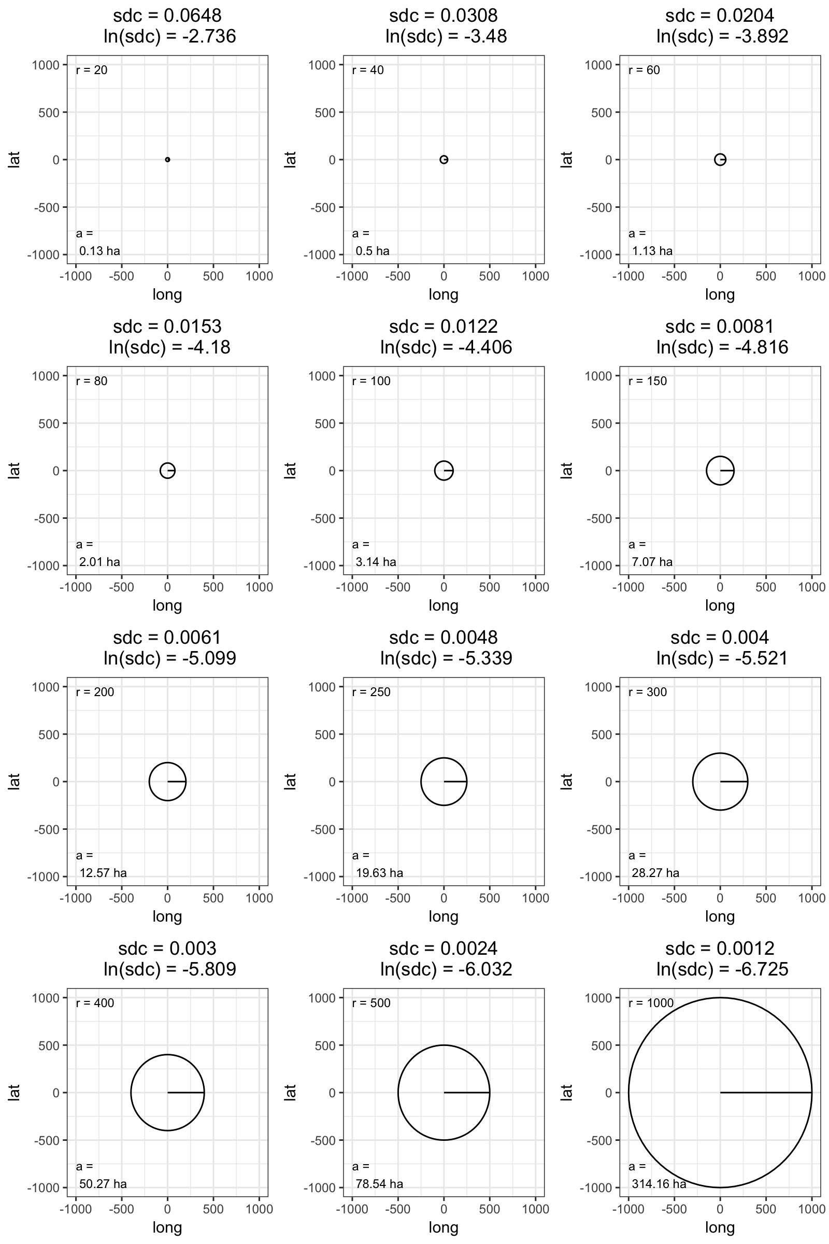

**Figure 2**: Regression tree based off model 2 (Table 1). Values in ovals are ln-transformed SDC values. Variables are fire management class (Suppression *SUP* or Wildland fire-use *WFU*), max high temperature during the burn window (max_tmmx), fire year (1984 through 2015), and fire management agency (National Park Service *NPS*, US Forest Service *USF*, CalFIRE *CDF*).

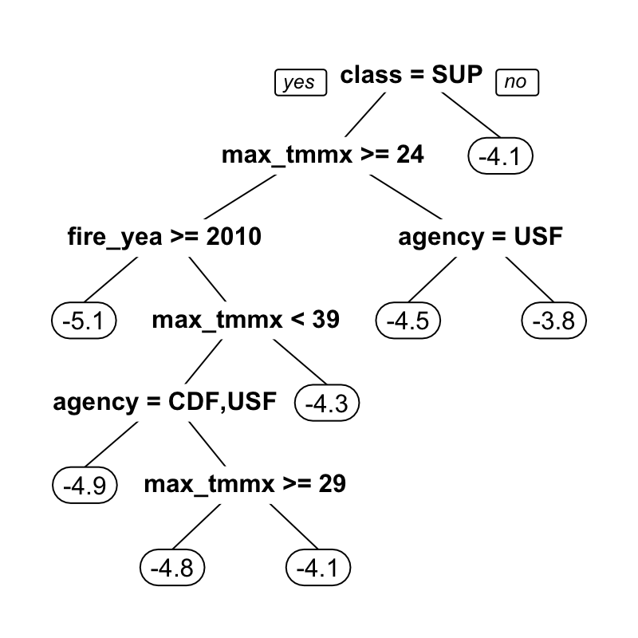

**Figure 3:**

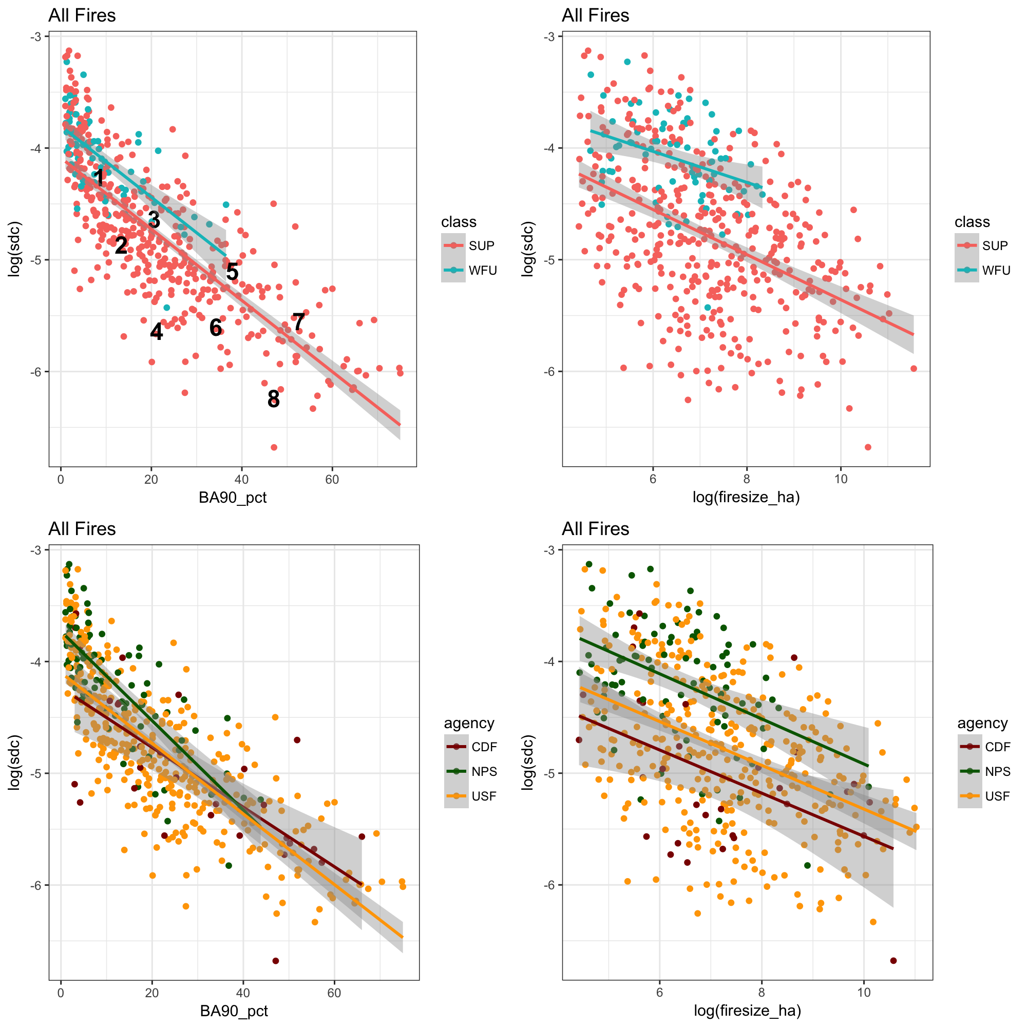

**Figure 4:** Trends in SDC, burn index and maximum high temperature over time.

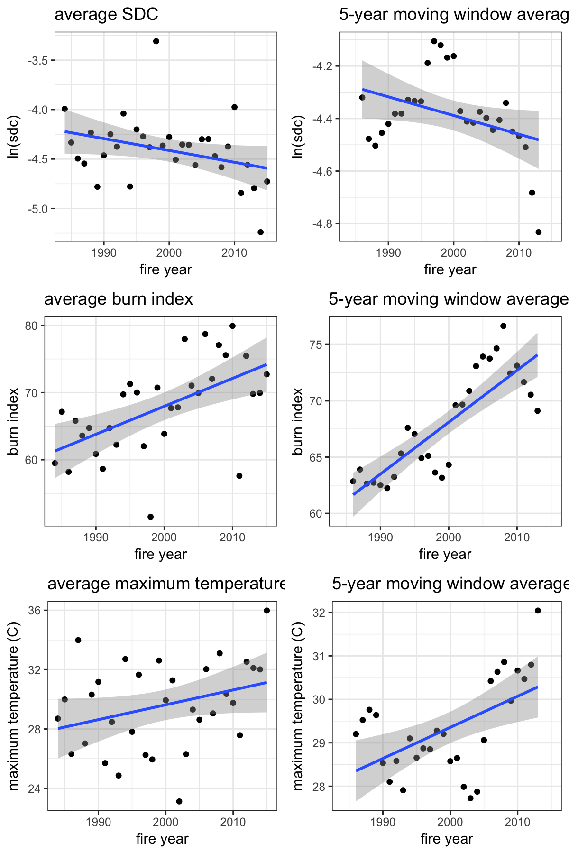

**Figure 5**: Examples of SDC for a range of fires. Fires in the same row have similar areas and percent high-severity, corresponding to numbers 1-8 in Fig. 3. (Details will be filled in). SDC values are shown on figure. Fires in the right column have lower SDC values than comparably-sized fires in the left column.

